PRACTICAL NO 4

1. Login to Oracle by user name given to you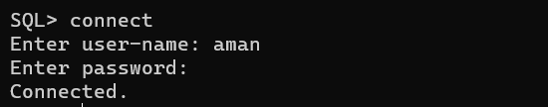
2. See list of tables by using ‘TAB’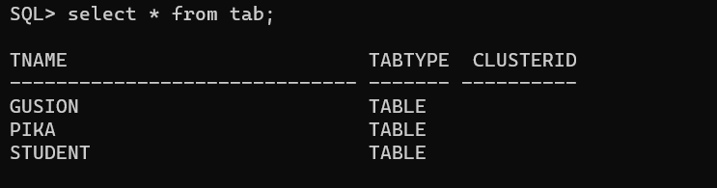

1. View the user name, make sure its your user name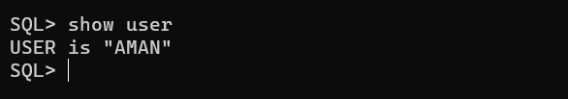
2. Create table name Employee with the following attributes and fields

|  |  |  |
| --- | --- | --- |
| Field Name | DataType | Size |
| EmpCode | Number |  |
| Name | VarChar | 6 |
| Salary | Number |  |



1. Display the structure of Table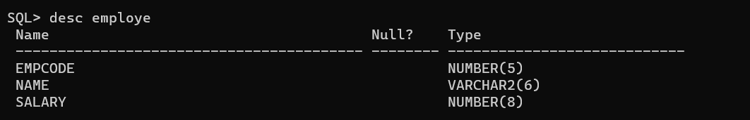
2. See the records of the Tables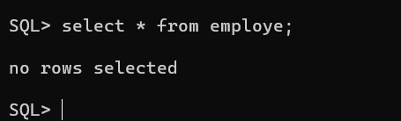
3. Insert the following data into Table using any method

|  |  |  |
| --- | --- | --- |
| EmpCode | Name | Salary |
| 101 | Amit | 30000 |
| 201 | Kapil | 22000 |
| 301 | Rohit | 45000 |
| 401 | Amit | 27000 |
| 401 | Amit | 27000 |

🡪 commit the data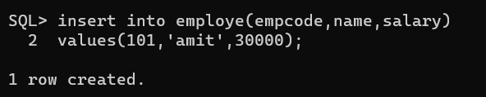

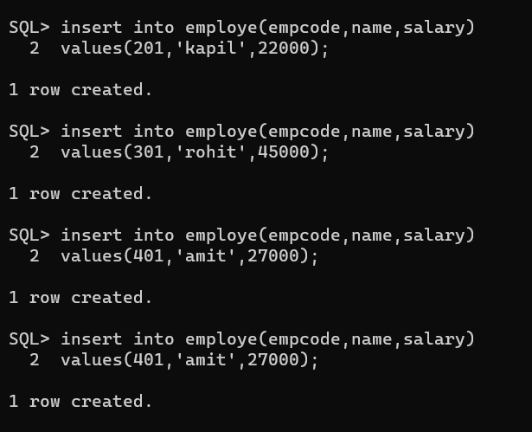

8.See the records of the table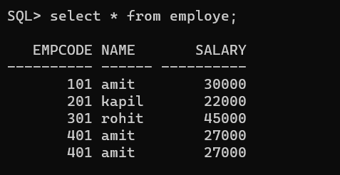

9.Try to add new following record

|  |  |  |
| --- | --- | --- |
| EmpCode | Name | Salary |
| 901 | Bhattacharya | 33000 |

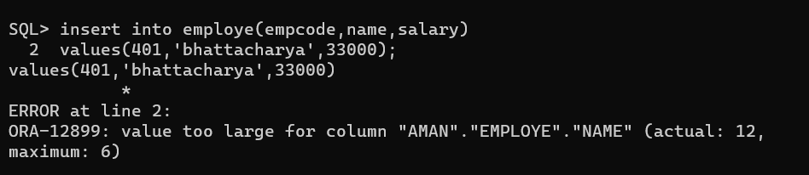

10.See the structure of table and note the size of name column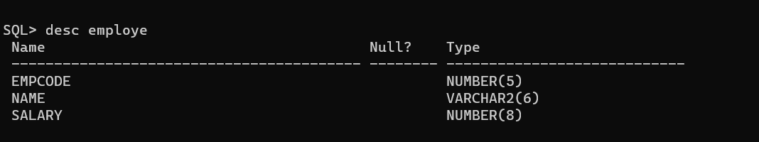

11.Increase the size of name column to 25 and see the structure of table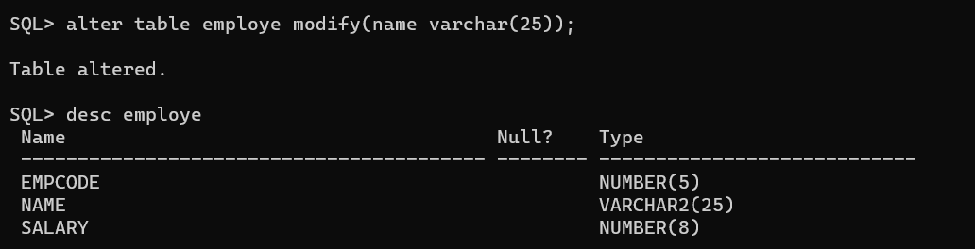

12. see the structure of the table again



13.See the record of the table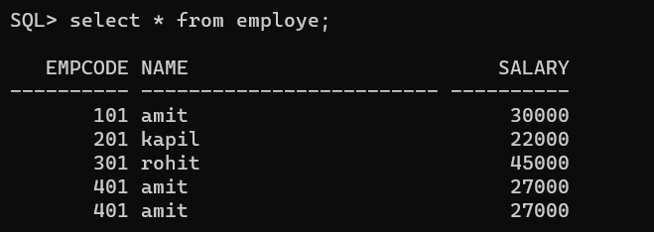

14.Now again try to add the above record again 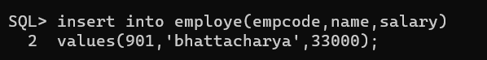

15. See the records of the table again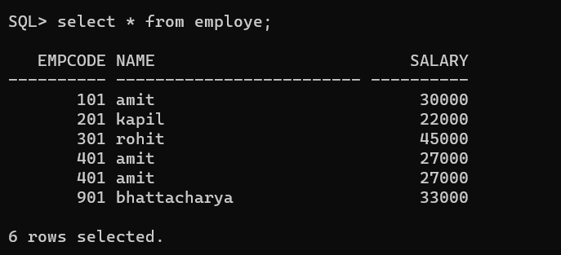

16.Reduce the size of name column to 5 and note the output again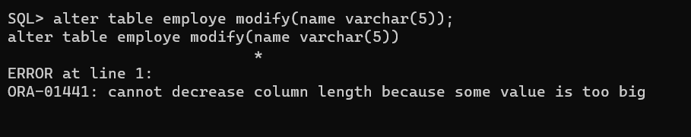

17.Commit the data and see all the records

